FastScripts – Online Pharmacy Application Design Document

Revision History
Date | Revision | Author | Description | Document Tracking
09/3/17 | 1.0 | Kelvin Huynh | First Design
09/14/17 | 1.1 | Kelvin Huynh | Hight-Level Use Case Diagram

Contents
1 Introduction 4
1.1 Intent 4
1.2 High Level Requirements 4
1.2.1 Registration 4
1.2.2 Authentication 4
1.2.3 Patient Registration 5
1.2.4 Filling Prescriptions 5
1.2.5 Payment and Confirmation 5
1.2.6 Medicine Inventory 5
2 FastScripts Use Cases 6
2.1 Intent 6
2.2 Interacting Use Cases 6
2.2.1 Use Case Diagram 7
3 Fully Dressed Use Case 8
3.1 Intent 8
3.1.1 Prescription Filling Use Case 8
3.2 Intent 10
3.2.1 Prescription Filling Use Case 10
4 Summary 12

Introduction

Intent
This is to document the requirements for the FastScripts application. It includes a use case diagram as well as two fully dressed use case, and other design details for the application.

High Level Requirements
FastScripts is an online company that provides a service to doctors that is looking to assist patients with their medication as well as prevent forged scrips and over prescribing of medication.

Originally Fastscripts only offered service in California, but with a constant interest from doctors as well as their patients Fastscript is planning to increase their area of service.

Registration

To register for the service the medical assistant at the doctor office would provide many information to prove that the user has the authority to request medication for patients.

The medical assistant would need to provide a national provider identification number (MPI address), office address, office phone number, their first name and last name, user id, password, work email, prescribing doctor’s first name and last, doctor’s email, and DEA number if the prescribing doctor is assigned one (for medication controlled by the United States Drug Enforcement Agency).

The registration process will confirm the entered information and send a confirmation email to the prescribing doctor for authorization.

Authentication

Medical assistants and doctors will be required to log in with a user id as well as a password. There will be an option to look up a user id and reset password.

Patient Registration
Medical assistants will be able to create a profile for the office’s patients, for this a few bits of information regarding the patient are needed. First name, last name, phone, date of birth, insurance provider, subscriber ID (policy number), and primary subscriber.

Filling Prescriptions

To fill prescriptions for patients, the user would have to look up the patient by patient last name and patient ID number. By entering pieces of information would insure that the right patient gets his or her medication.

The user is then able to look different menus to select the medication that is needed. Options such as: pain medication, antibiotics, antiviral, tropical/ointment, eye drops, cardiovascular drugs, diabetes management. After selecting a type of medication, the user can select the specific drug, the amount and different form if applicable. A scanned image of the physical script is also required and must be signed by the prescribing doctor.

After the medication has been selected the application would show how many of the medication has been filled for the patient in the last 6 months. This is to prevent over prescribing of medication.

Payment and Confirmation
After all medication is selected the payment and confirmation would check if the medicine is in stock and if it is not it will display when the medicine would be available to be shipped. If everything is correct the total cost would be calculated and the user has the option of either billing the insurance or billing the patient directly. After the user has confirmed the order, the system would update the warehouse inventory.

Medicine Inventory

Wearhouse administrator will be entering in the inventory of the medication in stock. This will include medicine form, amount of medicine (mg/ml), and next available shipment to warehouse.

FastScripts Use Cases

Intent
To list the uses cases in this application as well order the use cases by priority.

Interacting Use Cases

Listed high priority to low priority:
- Filling Prescriptions
- Payment and confirmation
- Medicine Inventory
- Patient registration
- Registration
- Authentication

Use Case Diagram

The diagram shows the interaction between the main actor (Medical Assistant) and the use cases.

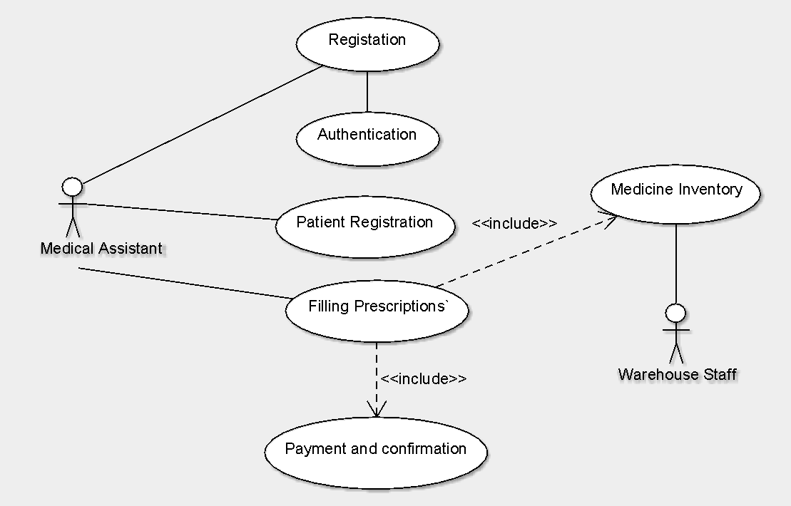
Figure 2-2-1 FastScripts Medical Assistant Interacting Use Case

High-Level Design for Prescription Filling Use Case

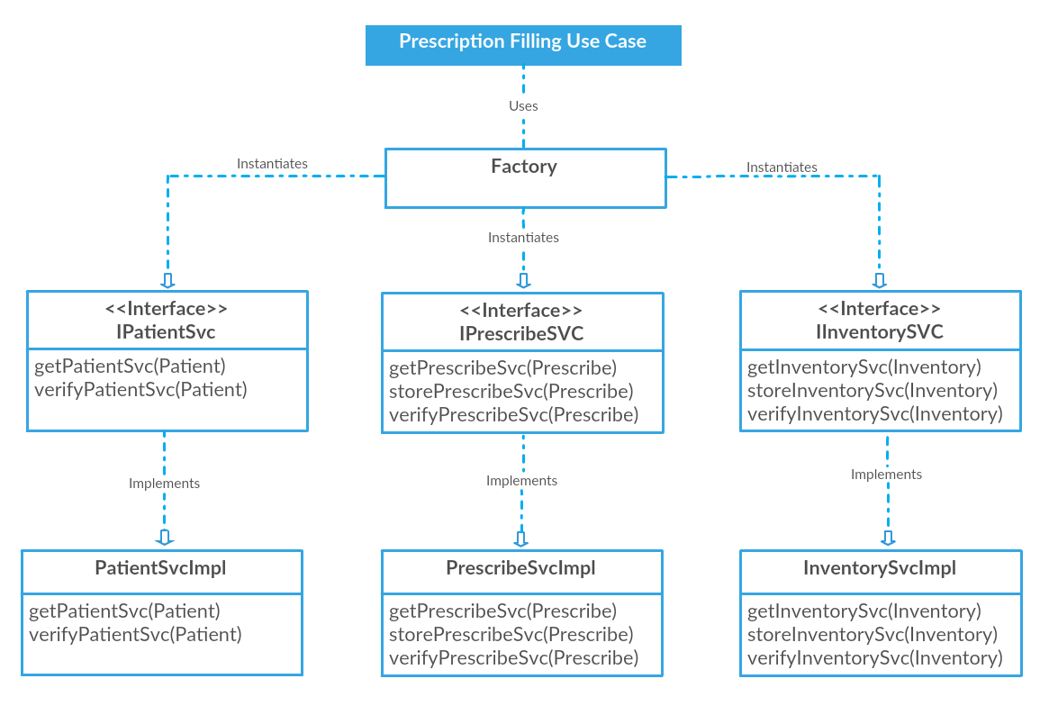
Figure 2-2-2 Prescription Filling High-Level Design Diagram

Fully Dressed Use Case

Intent
To document the fully dressed use case for filling a prescription for a patient.

Prescription Filling Use Case

Use Case name: Prescription Filling

Primary Actor: Medical Assistant

Stakeholders and interest: To ensure the correct patient is selected and the correct medication is selected.

Preconditions: Medical Assistant is registered and confirmed.

Success guarantee: Medication has been selected for the patient.

Main success scenario:
- User is asked to enter in patient last name and date of birth, so the correct patient is identified.
- System displays a list of type of medication that is available to order.
- User is to select one of the options that is displayed.
- System display a list of medication of the type the user selected.
- User selects the medication from the list the system displayed.
- System displays options that are available (pill, syrup, ect..)
- User selects of the of following options.
- System display prompts the user to enter in the dose (mg/ml), dosing (how many times per day), and dispense (the count per bottle).
- User enter in the dose (mg/ml), dosing (how many times per day), and dispense (the count per bottle).
- System ask the user if there is another medication that needs to be filled.
- User does not need to fill out any more orders.

Extensions:
1a. The information enter does not match any patient in the system.
-1a1. System prompts the user to enter the information again, just in case the information was entered incorrectly the first time.
-1a2. User leaves this use case to registrar the patient into the system.
3a. System does not have the medication type available.
3a1. User can select other, and type out the medication name manually, then continue to main success scenario 6.
5a. System does not have the medication available.

5a1. User can select other, and type out the medication name manually, then continue to main success scenario 6.
9a. Patient has an unusual number of prescription filled for the that medication type.
9a1. User is prompt with the recent prescriptions, and is asked to confirm the order.
11a. User needs fill out another medication order.
11a1. System starts at main success scenario 2.

Frequency of occurrence: Every time a prescription needed to be filled for a patient.

Intent
To document the fully dressed use case for payment and confirmation for a patient medication.

Prescription Filling Use Case

Use Case name: Payment and confirmation

Primary Actor: Medical Assistant

Stakeholders and interest: To ensure the correct information is entered for the cost and delivery of medication.

Preconditions: All medication has been selected for the patient.

Success guarantee: Medication has been ordered for the patient.

Main success scenario:
- System checks when the medication can be filled and shipped to patient.
- System displays the list of medication that was selected for the patient for confirmation and availability.
- User confirms the information is correct.
- System displays patient information: address, name, and date of birth.
- User confirms the information is correct.
- System ask if the user if the patient would want to bill the insurance company first.
- User is to enter in the patient medical insurance information.
- System is to ask the user to confirm the order.
- User confirms the order.
- System update the warehouse inventory.

Extensions:
1a. The medication supply is sufficient to fill the order.
-1a1. System will display the earliest date that medication can be shipped.
3a. Information displayed is not correct.
3a1. User select the medication that is not listed correctly.
3a2. System deletes the medication off the list.
3a3. User is sent to Prescription Filling use case.
3b. Shipping date is too late for the patient to be filled.
3b1. System ask the user if another medication needs to be added.
3b2. Medication is deleted from the list.
3b3. User is sent to Prescription Filling use case.
3c. A medication is not needed anymore.
3c1. Medication is delete from the list.
4a. System did not display the correct patient information.
4a1. System prompt the user to enter in patient’s first name.
4a2. User enters in patient’s first name.
4a3. System prompt the user to enter in patient’s last name.
4a4. User enters in patient’s last name.
4a5. System prompt the user to enter in patient’s address.
4a6. User enters in patient’s address.
4a7. System prompt the user to enter in patient’s date of birth.
4a8. User enters in patient’s date of birth

Frequency of occurrence: Every time a prescription needed to be filled for a patient.

Summary

This document contains the use cases used in the application, two fully dressed use cases, and a diagram of the interaction between the main actor and the use cases.

- End -

